Project Design Phase – Solution Architecture

Date: 25 October 2026
Team ID: __________
Project Name: StaffSync – Human Resource Management System
Maximum Marks: 4 Marks

- Solution Architecture

StaffSync is a web-based Human Resource Management System designed to manage employee records, attendance, and leave requests. It uses React.js for the frontend, Node.js and Express.js for the backend, and MongoDB for storing data.

The architecture connects the user interface to the backend API, which processes requests and communicates with the database.

- Key Components

- Frontend: React.js provides the user interface and dashboard.
- Backend: Node.js and Express.js handle application requests and business logic.
- Database: MongoDB stores employee information, attendance records, and leave requests.
- API Communication: REST APIs connect the frontend with the backend.
- Data Management: The application retrieves, updates, and stores records in the database.

- Example – Solution Architecture Diagram

User / HR Administrator
↓
Frontend – React.js
↓
Backend API – Node.js + Express.js
↓
Database – MongoDB Atlas

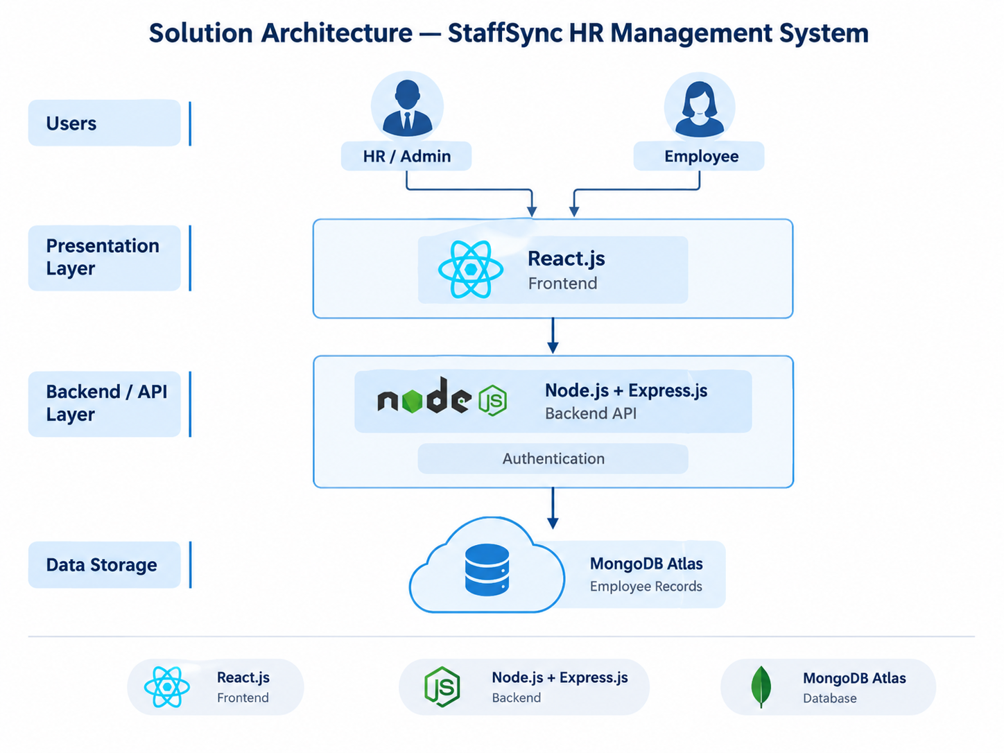

- Working Process

1. The user interacts with the StaffSync frontend.
2. The frontend sends requests to the backend API.
3. The backend processes the requests and communicates with MongoDB.
4. MongoDB stores or retrieves the required information.
5. The backend returns the response, and the frontend displays the result.

- Conclusion

StaffSync uses a simple three-layer architecture consisting of the frontend, backend, and database. This structure makes the application easier to manage and provides a foundation for adding more HR features in the future.

